PHASE 6: PROJECT DOCUMENTATION

6.1 Testing and Validation
The developed system must be tested using different ticket descriptions.

Test Case 1 – Wi-Fi
Caller: Student
Short Description:
WiFi not working in library
Expected:
Category: Network
Subcategory: Wi-Fi
The system should also send an email to the caller.
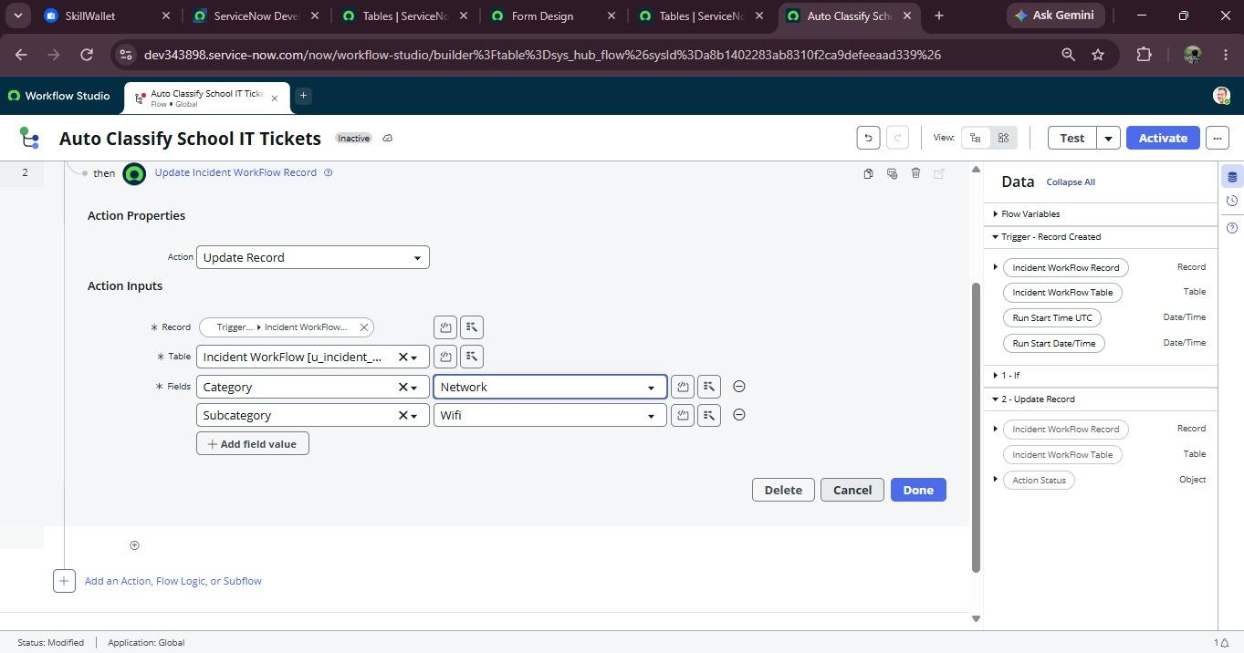
- Caller
- Short Description
- Category = Network
- Subcategory = Wi-Fi

6.2 Test Case 2 – Projector
Short Description:
Projector not turning on
Expected:
Category: Hardware
Subcategory: Projector
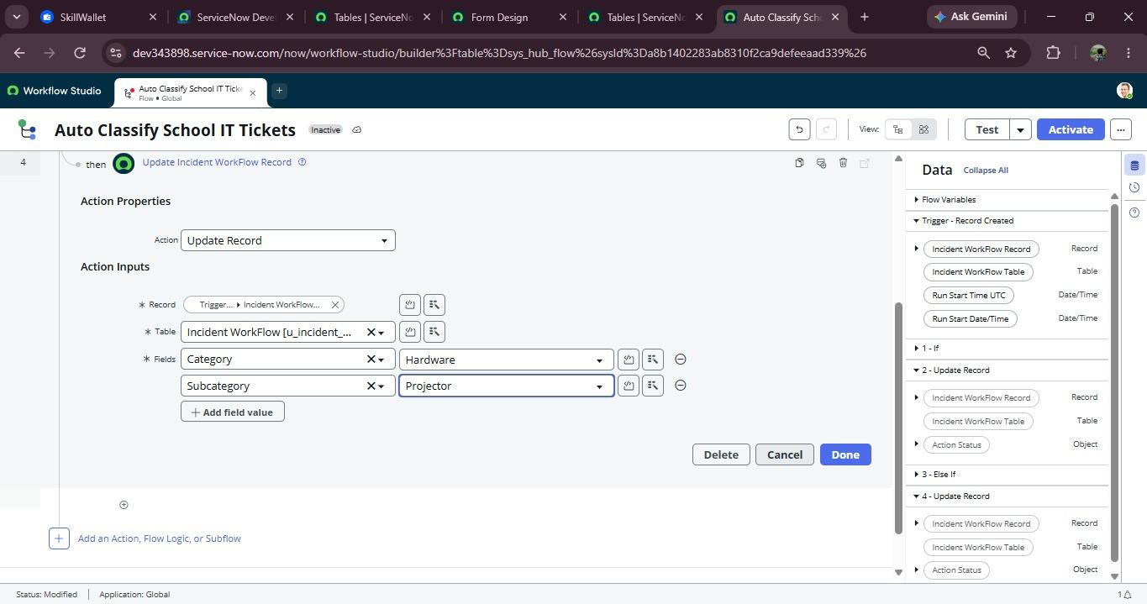
- Caller
- Short Description
- Category = Hardware
- Subcategory = Projector

6.3 Test Case 3 – Password
Short Description:
I forgot my password
Expected:
Category: Access
Subcategory: Forgot Password

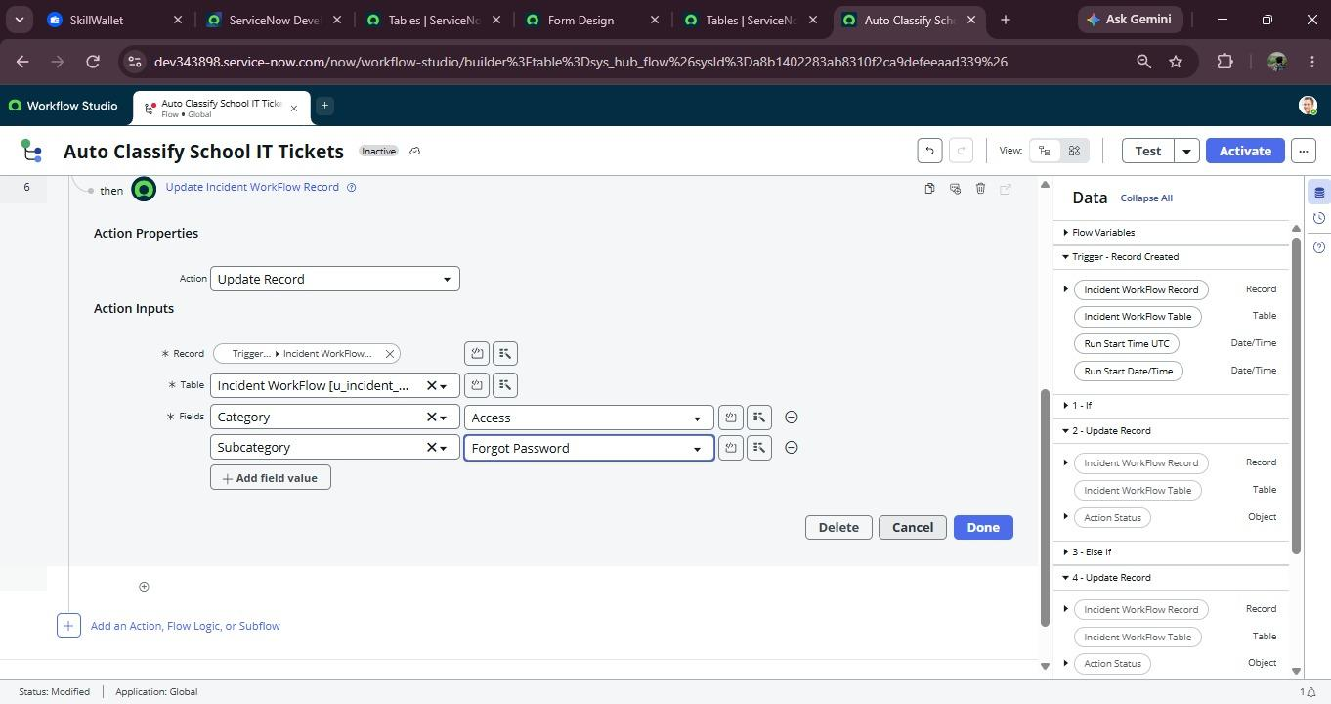

- Caller
- Short Description
- Category = Access
- Subcategory = Forgot Password

6.4 Test Case 4 – Slow Computer
Short Description:
Computer is very slow
Expected:
Category: Performance
Subcategory: Slow Computer
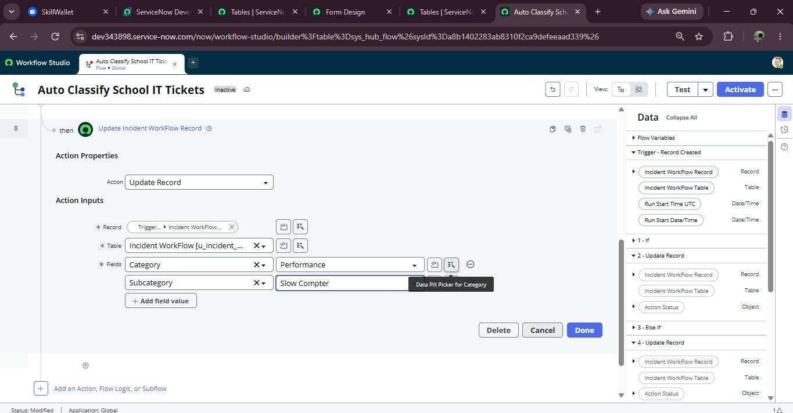
- Caller
- Short Description
- Category = Performance
- Subcategory = Slow Computer

6.5 Email Validation
Navigation:
All → System Logs → Emails
Search using the email subject.
Open the email record and select:
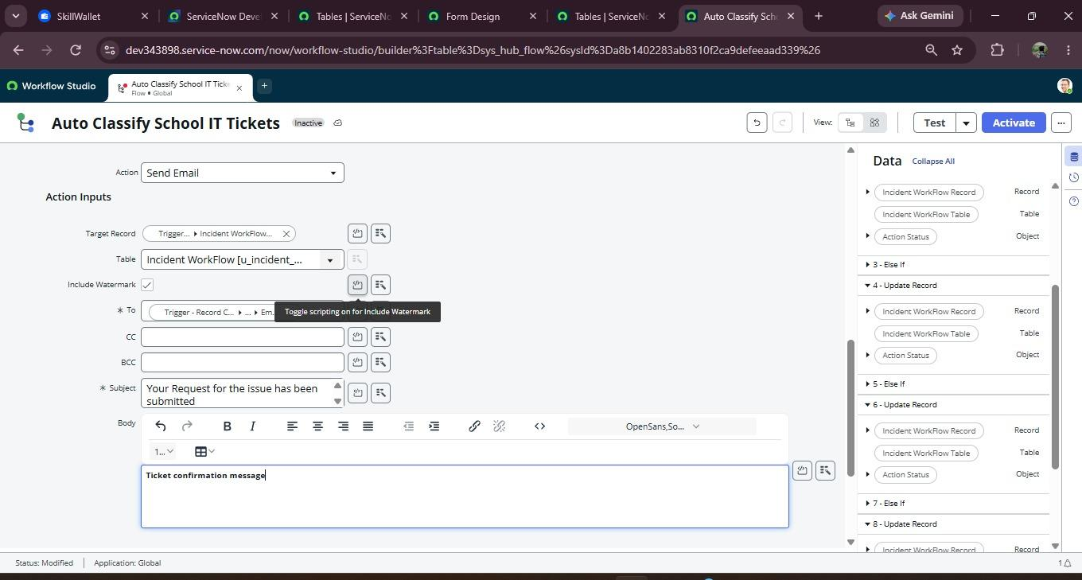
Preview Email
Verify that the notification was successfully generated.

6.6 Data Validation
Verify:
- Auto number is generated.
- Caller reference is correct.
- Category is correctly assigned.
- Subcategory is correctly assigned.
- Category/Subcategory dependency works.
- Email is sent.
- Ticket information is stored correctly.

6.7 Conclusion
The Auto Ticket Classification using Flow Designer system was successfully tested and validated using different types of IT support tickets. The system correctly identifies the category and subcategory based on the ticket description. The required ticket information is stored correctly, and email notifications are generated successfully. The testing confirms that the system works as expected and helps automate the IT ticket classification process.

